<Publishing House Details>

<Journal Name>

Vol. 1 (2020), India

*Research Article*

# Real Time Face Recognition Based Attendance System

# Pawan kumar, Tushar Anand, Debashis Patra, Prof. Manoj Kumar Behera

*Department of Computer Science and Engineering, Centurion University of Technology and Management*

**Abstract** – Face detection technology has widely attracted attention due to its enormous application value and market potential, such as face recognition and video surveillance system. Real-time face detection not only is one part of the automatic face recognition system but also is developing an independent research subject. So, there are many approaches to solve face detection. This paper introduces a new approach in automatic attendance management systems, extended with computer vision algorithms. We propose using real time face detection algorithms integrated on an existing Learning Management System (LMS), which automatically detects and registers students attending on a lecture. The system represents a supplemental tool for instructors, combining algorithms used in machine learning with adaptive methods used to track facial changes during a longer period of time. This new system aims to be less time consuming than traditional methods, at the same time being nonintrusive and not interfere with the regular teaching process.

**Keywords** Objectdetection; object recognition; real time; neural networks; internet of things; visually impaired

# Introduction

A key factor of improving the quality of education is having students attend classes regularly. Traditionally students are stimulated to attend classes using attendance points which at the end of a semester constitute a part of a students’ final grade. However, traditionally this presents additional effort from the teacher, who must make sure to correctly mark attending students, which at the same time wastes a considerable amount of time from the teaching process. Furthermore it can get much more complicated if one has to deal with large groups of students. This paper introduces a new automatic attendance management marking system, without any interference with the regular teaching process. The system can be used also during exam sessions or other teaching activities where attendance is obligatory. This system eliminates classical student identification such as calling student names, or checking respective identification cards, which can not only interfere with the teaching process, but also can be stressful for students during exam sessions.

**2.Related Works**

Face recognition has been initiated in the year 1960’s with the marking of features on the photographs, the major features were eyes. nose, ears, lips and mouth. Then distances and the ratios were computed to a common referential point from these marks and comparison to reference data. Facial recognition is a biometric based recognition system. There are several factors which are necessary for an advance face recognition system:

A. The time taken from the detection of face to the recognition of face should be admissible.

B. The precision and accuracy of the system should be significant in nature.

C. The system should be ready for the enlargement, i.e. the number of objects to be recognition can be increased and the system should be adaptable.

D. Several face Recognition Methods Are

1) Holistic matching approach: In this approach, the complete region of the face is taken as input data with complete face recognition. Eigenfaces, Principal Component Analysis, Independent Component Analysis, Linear Discriminant Analysis are the examples of the holistic matching method of face recognition.

2) Feature-based approach: In this approach features like mouth, nose, eyes, lips are extracted and their locations from the common reference point are fed to the structural classifier. Feature restoration is an immense challenge in this approach.

3) Hybrid approach: This approach is the amalgamation of the holistic approach and feature-based approach. The hybrid approach uses three-dimensional images. The image of the human being is captured in three-dimension. It permits the system to capture the minute details such as curves near the eye, the shape of the chin, depth near the nose, the shape of the forehead and thickness of the lips. The three-dimensional hybrid approach of face recognition is a five-step process. These five-steps are Face Detection, Position of the face, Measurement of the features from the common reference point, Representation and at last the process of Matching.

Now these days, in institutes and colleges, the number of students is increasing significantly, and the conventional method of attendance marking is too much time taking. The conventional method of attendance marking includes maintaining the logs and registers by calling the names of students and passing the attendance sheet to the students. The automated attendance marking systems are Iris recognition, fingerprint recognition, and Radio-frequency Identification and Detection. RFID is the attendance marking system which is quite popular these days.

# PROPOSED METHODOLOGY

# This is the archetype model of Real time face recognition-based attendance monitoring system. The camera and the system which is installed at the centre of the front facing to a cicle. The camera detects the faces in a video-frame who ever stand inside of the circle. Initially the captured faces are cropped later converted to the grey scale which results in reduction in the number of bits which is going to be used in image processing. Then, there is a comparison of these faces with the existing faces in the database marking of their attendance.

# A. Creation of Students Database

# 20-25 photographs of each student are captured in different angles with some modification and gestures. The images are in the form of RGBE which are further cropped and converted into grey scale and finally resize to 124*96 pixels for the reduction in the time of computation. All the images are put into the folder named “Student Database”, each folder is further divided into sub-folders, subfolder is named on the name of the student. Sub-folder contains multiple images of each student.

# C:\Users\Debashis\Desktop\55208772-730c2280-5205-11e9-928d-475c07118af4.png

Figure 1: Multiple images of a single person in the database

# **Haar Cascade Classifiers :**We will implement our use case using the Haar Cascade classifier. Haar Cascade classifier is an effective object detection approach .

# ****Face Detection****

In this case we will try to detect the face of individuals using the **haarcascade_frontalface_default.xml**

The dimensions of the image that we have used here was pretty large, so we have scaled down the image dimensions for better output.

I have downloaded the xml file to my local and used the path of my machine.

Generally the images that we see are in the form of RGB channel(Red, Green, Blue). So, when OpenCV reads the RGB image, it usually stores the image in BGR (Blue, Green, Red) channel. For the purposes of image recognition, we need to convert this BGR channel to gray channel. The reason for this is gray channel is easy to process and is computationally less intensive as it contains only 1-channel of black-white.

From the above step, the function **detectMultiScale**returns 4 values — x-coordinate, y-coordinate, width(w) and height(h) of the detected feature of the face. Based on these 4 values we will draw a rectangle around the face.

**Training the Algorithm:** First, we need to train the algorithm. To do so, we need to use a dataset with the facial images of the people we want to recognize. We need to also set an ID (it may be a number or the name of the person) for each image, so the algorithm will use this information to recognize an input image and give you an output. Images of the same person must have the same ID. With the training set already constructed, let’s see the LBPH computational steps.

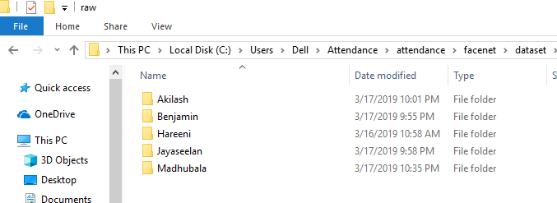

Figure 2: Different folder for different student name as id.

**Attendance Marking:** After extracting the name of the matched face corresponding attendance is marked in the work sheet and the database containing all the attendance records will also be updated on the same.

# IMPLEMENTATION

# GUI (Graphical User Interface)

# This is the graphical user interface of our Real time face recognition-based attendance monitoring system. It consists an area for the 2-dimensional image which is going to be either captured from the webcam or browsed from the local disk of the system. Training, Start camera, Take photo, Browse image, Start Counting, Generate Attendance Report are the buttons of Real Time face recognition based attendance monitoring system.

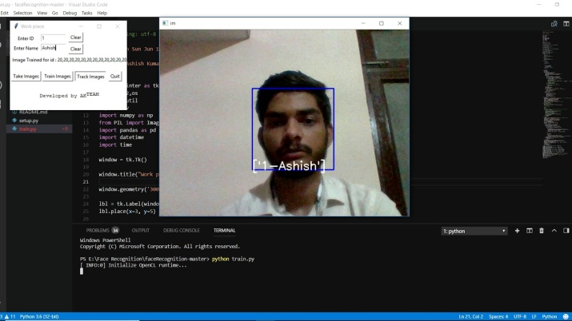

Figure 3: Real Time Object Recognition

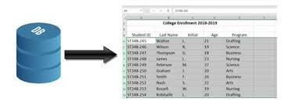

Figure 4: Attendance report is generated

# Conclusion

# This Real Time face recognition-based attendance monitoring system can record the attendance of students in a classroom or the attendance of the employees in an organization. It takes only 2-3 minutes for recording and updating the attendance. This is very easy and convenient method of attendance marking. If this is implemented in colleges and institutes, then it will save a lot of time of teachers and the students. This method is very cost efficient as it requires Camera, Laptop and local network. This system is more secure and trustworthy in compare to the conventional methods of attendance marking

# 6 Future Scope

# Altogether the cheats of ATM it is prescribed to set up the database of all the ATM clients with the banks and organization of high resolutions camera and face acknowledgment programming by any stretch of the imagination. To maintain a strategic distance from the copy voters, a database of all voters of all bodies electorate is prescribed to be ready. At that point at the season of voting determination camera and the face acknowledgment supplies at the voting site could help in distinguishing pieces of proof of the voters. In barrier service and all other imperative places, the face acknowledgment innovation can be sent for better security.

# .

# 7 References

[1]. Visar Shehu, Agni Dika, “Using Real Time Computer Vision Algorithms in Automatic Attendance Management Systems” ITI 2010 32nd Int. Conf. on Information Technology Interfaces, June 21-24, 2010, Cavtat, Croatia.

|  |
| --- |
|  |

[2]. PAN Xiang, “Research and Implementation of Access Control System based on RFID and FNNFace, 2012 International Conference on Intelligent Systems Design and Engineering Application 12 2012 2012.400 Recognition”, 978-0-76954608-7/11 $26.00 © 2011 IEEE

# [3]. Mr.Jitendra B. Jawale Ear Based Attendance Monitoring System Proceedings of ICETECT 2011, 978-1-4244-79269/11/$26.00 ©2011 IEEE

# [4]. Jian Xiao, Gugang Gao, Chen Hu, Haidong Feng “A Novel Framework for Fast Embedded Face Detection System”, 14244-1132-7/07/$25.00 © 2007 IEEE

# [5]. Jing Bian, Wei Du, “Research of Face Detection System Based on Skin-Tone Feature”, 978-1-61284-722-1/11/$26.00 ©2011 IEEE

# [6]. Nai-Jian Wang “A Real-time Multi-face Detection System Implemented on FPGA”, 2012 IEEE International Symposium on Intelligent Signal Processing and Communication Systems (ISPACS 2012) November 4-7, 2012

# [7]. Xianghua Fan, Fuyou Zhang, Haixia Wang, Xiao Lu, “The System of Face Detection Based on OpenCV”, 978-1-45772074-1/12/$26.00_c 2012 IEEE

# [8]. Yohei Ishii, “Face and Head Detection for a Real-Time Surveillance System”, Proceedings of the 17th International Conference on Pattern Recognition (ICPR’04) 1051-4651/04 $ 20.00 IEEE

# [9]. Rahul Chandrasekaran, “Security Assurance Using Face Recognition & Detection System Based On Neural Networks”, The 2005 IEEE International Conference on Neural Networks and Brain ICNN&B'05

# [10]. Phuong-Trinh Pham-Ngoc, “Multi-face Detection System in Video Sequence”, 1-4244-0427-4/06/$20.00 ©2006 IEEE

# [11]. Lejla Abazi-Bexheti. Development of a Learning Content Management System. WSEAS Transactions on Information Science and Applications.

# View